

Project Management

Assessment Two



70309 Sang ah Park

|  |  |  |  |
| --- | --- | --- | --- |
| Name of Student | Sang ah Park | ID | 70309 |

Assessment 2 – Research (Online)

Contents

Instructions: 1

Duration: 2

Multiple-choice Questions: 2

Learning Notes: 7

What is project? 8

Please put your learning notes here: 8

Project management basic 8

Project management History 8

Project management in the future 9

Project Team 10

Document Search Index 10

## Instructions:

This is an individual assessment. Answer all the questions on the document provided by your Trainer.

## Duration:

Trainer will set the duration of the assessment.

## Multiple-choice Questions:

1. What advice do we give about factoring in the commitments of project stakeholders when making your own plans?
   1. Consult student timetables to see when they might be free to attend data collection sessions.
   2. Ask external organizations what the most convenient times would be for you to visit
   3. Neither of these

d) Both A and B

**Comment:** Effective communication with stakeholders remove hurdles, save time and more importantly ensure delivery of the project within the time and budget constraints.

**Reference:** <https://sustainet.com/managing-stakeholder-commitments/>

1. Which of the following are essential components of a GANTT chart used to plan your project?
   1. Your home telephone number
   2. Your supervisor’s home telephone number
   3. The email address for the chair of the ethics committee
   4. None of the above

**Comment:** Typically, a Gantt chart include components such as dates, tasks, milestones, taskbars, task ID, and resources information (hourly rate, availability).

**Reference:** <https://www.liveabout.com/gantt-chart-components-2779538>

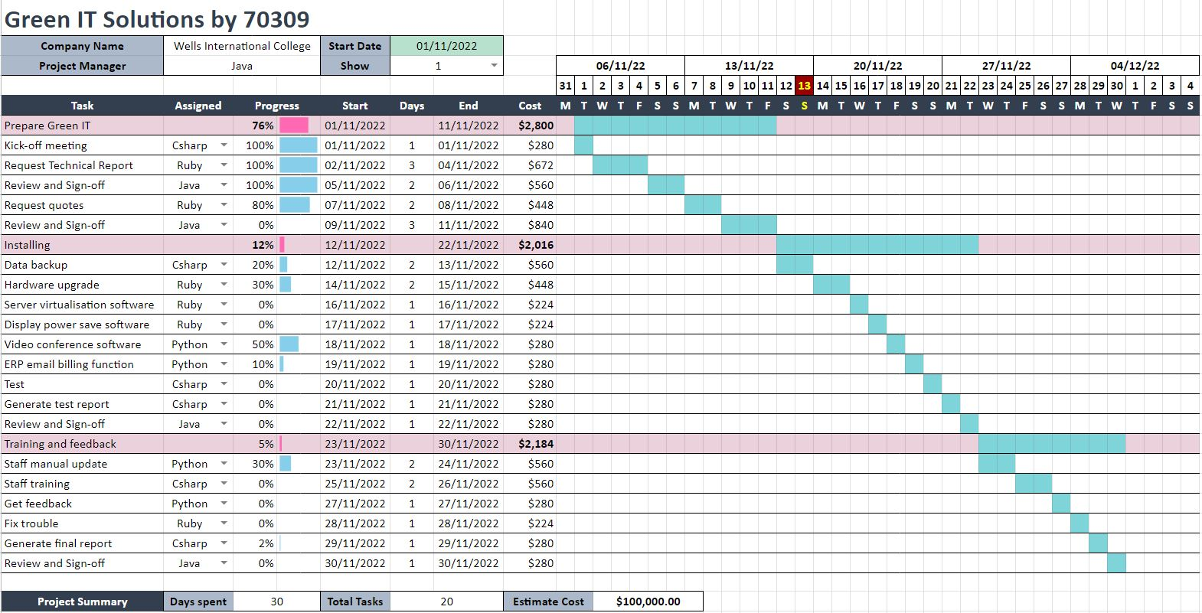

1. The intended outcome of strategy/projects integration is
   1. Clear organization focus
   2. Best use of scarce organization resources
   3. Improved communication across projects and departments
   4. Both A and C are correct
   5. A, B, and C are all correct

**Comment:** Project integration management is the coordination of all aspects of a project, including its processes and related systems, to ensure that a project is well executed.

**Reference:** https://www.kantata.com/blog/article/the-importance-of-project-integration-management

1. Which of the following questions does the organization's mission statement answer?
   1. What are our long-term strategies?
   2. What are our long-term goals and objectives?
   3. How do we operate in the existing environment?
   4. What do we want to become?
   5. All of these are answered by the mission statement

**Comment:** A mission statement is a concise explanation of the organization's reason for existence.

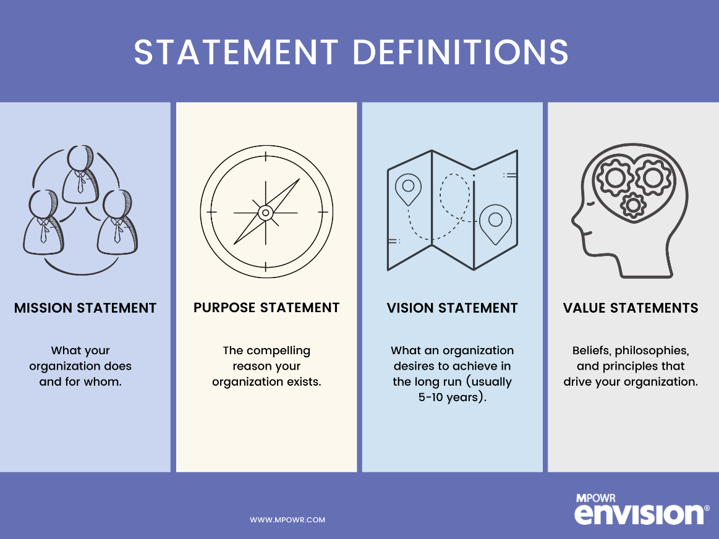**Reference:** <https://www.shrm.org/resourcesandtools/tools-and-samples/hr-qa/pages/isthereadifferencebetweenacompany%E2%80%99smission,visionandvaluestatements.aspx#:~:text=A%20mission%20statement%20is%20a,customers%2C%20vendors%20and%20other%20stakeholders>.

1. Which of the following is not one of the requirements for successful implementation of strategies through projects?
   1. Allocation of resources
   2. Prioritizing of projects
   3. Motivation of project contributors
   4. Adequate planning and control systems
   5. All of these are requirements

**Comment:** Successful implementation of strategies can be achieved by setting clear goals, defining key variables, roles, responsibilities, and relationships. Project manager should monitor progress and performance, and provide continued support.

**Reference:** <https://online.hbs.edu/blog/post/strategy-implementation-for-managers>

1. Which of the following is the reason(s) why project managers need to understand their organization's mission and strategy?
   1. To make appropriate decisions and adjustments
   2. To be effective project advocates
   3. To be able to get their job done
   4. Both A and B are correct
   5. A, B, and C are all correct

**Comment:** Strategies are critical to the success of an organization because this is where you begin outlining a plan for doing something.

**Reference:** https://www.extension.iastate.edu/agdm/wholefarm/html/c5-09.html#:~:text=Mission%20is%20a%20general%20statement,timelines%20for%20achieving%20the%20goal.

1. Which of these is the highest priority and first strategy required for any organizational change?

a) Communication

* 1. Stress management
  2. Negotiation
  3. Learning
  4. Employee involvement

**Comment:** Properly communicating on a project is a critical success factor for managing the

expectations of the client and the stakeholders.

**Reference:** Leaner’s guide p.65

1. Which of the following is not a procedure to obtain an understanding risk in the planning stage (described in ISA 315):
   1. Inquiries of management
   2. Analytical procedures
   3. Observation and inspection
   4. Procedures for sampling audit tests

**Comment:** Risk management planning, risk identification, qualitative risk analysis, quantitive risk analysis, risk response planning

**Reference:** https://leaccountant.com/isa-315-summary/

1. Assessment of control risk includes three steps. Which of the following is not one of these steps?
   1. Obtaining an understanding of internal controls and documentation of the controls
   2. Evaluate sufficiency and appropriateness of audit evidence
   3. An initial assessment and response to assessed risk based on the design of internal controls resulting in an audit planning memorandum and audit plan
   4. A final assessment based upon test of controls of operating effectiveness

**Reference:** https://www.iedunote.com/control-risk

1. Which of the following are not common internal control documentation techniques used by auditors?

a) Questionnaires

* 1. Company internal control manuals
  2. Narrative descriptions
  3. Check lists

**Comment:** Examples of audit documentation include memoranda, confirmations, correspondence, schedules, audit programs, and letters of representation. Audit documentation may be in the form of paper, electronic files, or other media.

**Reference:** https://smallbusiness.chron.com/seven-internal-control-procedures-accounting-76070.html

1. Overall response to assessed risk may include:
   1. Identify the absence of key controls (where controls are lacking)
   2. Identify existing controls
   3. Incorporating additional elements of unpredictability in the selection of further audit procedures to be performed
   4. Determine potential material misstatements that could result

**Reference:** <https://pcaobus.org/oversight/standards/auditing-standards/details/AS2301>

1. Action plan Should be
   1. Specific
   2. Countable
   3. Realistic
   4. Achievable

**Comment:** Action plans include the goal, activity, responsibilities, resources, timeline, evidence of success, evaluation process.

**Reference:** https://ctb.ku.edu/en/table-of-contents/structure/strategic-planning/develop-action-plans/main#:~:text=Develop%20an%20action%20plan%20composed,your%20objectives%20and%20your%20strategies.

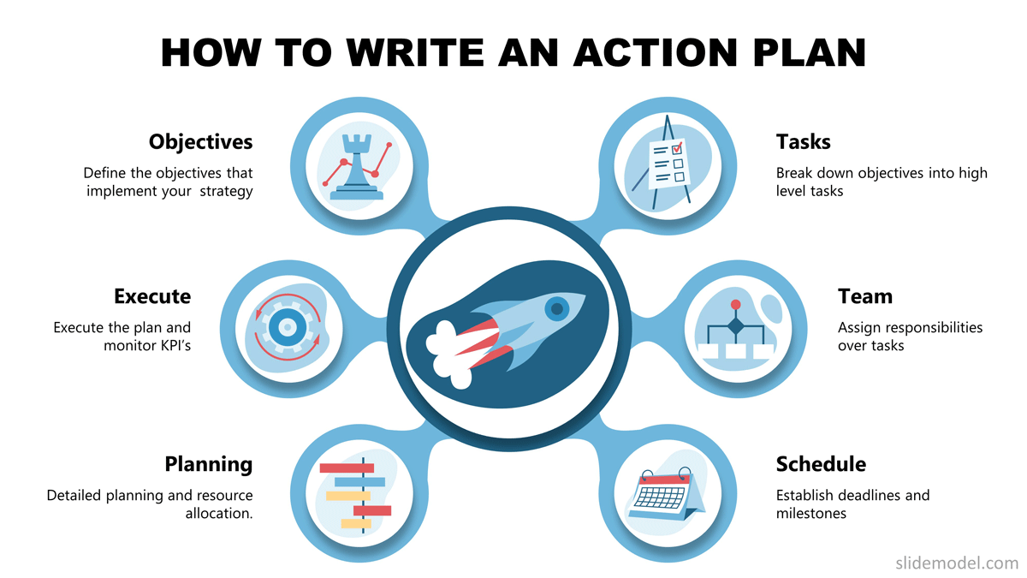

1. Which of the following is not a function of Project Management Tool?
   1. Plan a project
   2. Manage Tasks
   3. Manage Issues
   4. Time Tracking
   5. None of above

**Comment:** Using project management tools is an effective way to deliver projects on time and organize tasks. It is the way to track progress and manage time for successful projects.

**Reference:** https://www.wrike.com/project-management-guide/faq/what-are-project-management-tools/

1. John, the project manager for the ERP Project, is about to complete the project phase review. The completion of a project phase is also known as which of the following?

a) A lesson learned

* 1. A kill point
  2. Earned value management
  3. Conditional advancement

**Comment:** Earned value management (EVM) is a project management methodology that integrates schedule, costs, and scope to measure project performance. Based on planned and actual values, EVM predicts the future and enables project managers to adjust accordingly.

**Reference:** <https://www.pmi.org/learning/library/earned-value-management-systems-analysis-8026>

1. Which of the following is not a key stakeholder in a project that creates a service internal to an organization?
   1. The project manager
   2. External customers
   3. Project vendors
   4. Project team members
2. Managing a project is best described as which one of the following?
   1. Establishing direction
   2. Functional controls over the project team and stakeholders
   3. Consistently producing key results expected by stakeholders
   4. Motivating and inspiring the project team to produce results that are expected by project stakeholders

**Comment:** the purpose of project management is to plan and manage a project to successfully complete its listed goals and deliverables. It involves identifying and managing risks, careful resource management, smart budgeting, and clear communication across multiple teams and stakeholders.

**Reference:** https://www.lucidchart.com/blog/why-is-project-management-important

1. You are the project manager for your organization. Influencing your organization requires which of the following?
   1. An understanding of the organizational budget
   2. Research and documentation of proven business cases
   3. An understanding of formal and informal organizational structures
   4. Positional power

1. What is the difference between a standard and a regulation?
   1. Standards are mandatory; regulations are not.
   2. Standards are optional; regulations are not.
   3. Regulations and standards are essentially the same.
   4. Regulations are usually mandatory; standards may be seen as guidelines.

**Comment:** Standards make things work by providing specifications (guidelines or requirements) for products, services and systems, whereas regulations are detailed instructions on how laws are to be enforced or carried out and are sometimes referred to as “rules” or “administrative laws.” They carry the force of law – their application is mandatory.

**Reference:** https://www.focusstandards.org/standards-vs-regulations-vs-laws/

1. Which of the following is an example of a deliverable at the end of the requirements-gathering phase in a software design project?
   1. Responsibility matrix creation
   2. Detail design document
   3. Business needs
   4. Project team assembled

**Comment:** Requirement gathering process includes

* Identify the relevant stakeholders.
* Establish project goals and objectives.
* Elicit requirements from stakeholders.
* Document the requirements.
* Confirm the requirements.
* Prioritize the requirements.

**Reference:** https://www.jamasoftware.com/requirements-management-guide/requirements-gathering-and-management-processes/what-is-requirements-gathering

1. At what point in a project would a kill point be acceptable?
   1. When a project team member is not performing as planned
   2. When a project reaches the end of a project phase
   3. When a project reaches the end of its budget
   4. When a project manager determines the project team cannot continue

**Comment:** The term “kill point” is used in project management to determine whether the project should stop work or move to the next phase. The technical team presents its case to leadership, and a decision is made on the project's life.

**Reference:** https://www.threetinstitute.com/blog/killpoint

1. Of the following, which is not an exit criterion?
   1. Customer sign-offs
   2. Quality metrics
   3. Stakeholder analysis
   4. Regulatory inspections

**Comment:** A stakeholder analysis is a process of identifying these people before the project begins.

**Reference:** https://www.productplan.com/glossary/stakeholder-analysis/

1. At which point is the risk of failure the least but the consequence of failure the highest?

a) During the early stages

* 1. During the middle stages
  2. During the final stages
  3. Risk of failure is even across all project phases

1. In project estimation, project manager has to provide an expert judgement, which are considered of the following EXCEPT:
   1. Impact of inflation over the project lifecycle
   2. Required labour and labour rates
   3. Material costs and assumptions
   4. Costs of quality
   5. All of above
   6. None of above

**Comment:** the process of analyzing available data to predict the time, cost, and resources needed to complete a project. Typically, project estimation includes scope, time-frames, budget, and risks.

**Reference:** https://ncube.com/blog/project-estimation-definition-anatomy-and-approaches

1. Which component is/are included in Quality Management Plan
   1. 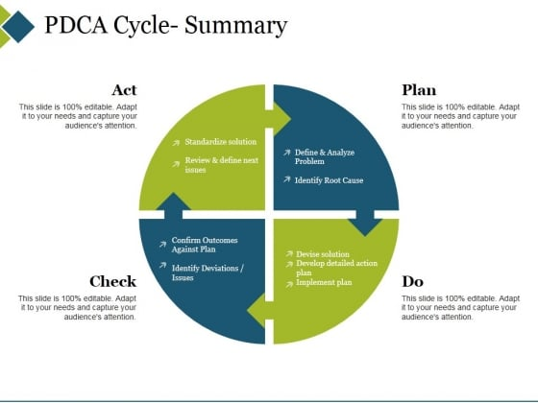Quality objectives
   2. Key project deliverables
   3. Quality standards
   4. Quality control and assurance activities
   5. All of above

**Comment:** The Quality Management Plan documents the necessary information required to effectively manage project quality from project planning to delivery. It defines a project's quality policies, procedures, criteria for and areas of application, and roles, responsibilities and authorities.

**Reference:** https://en.wikipedia.org/wiki/Quality_management

1. What's an activity sequencing
   1. The process for identifying and documenting dependencies among schedule activities
   2. The process for identifying critical activities
   3. The process for identifying ordering and schedule activities
   4. The process for planning the project

**Comment:** Sequence Activities is the process of identifying and documenting relationships among the project activities. A benefit of this process is that it identifies a logical sequence of work, which in turn will help the project team work more efficiently. Let's look at an example of defining and sequencing activities.

**Reference:** https://www.futurelearn.com/info/courses/time-management-project-management/0/steps/136200#:~:text=Sequence%20Activities%20is%20the%20process,of%20defining%20and%20sequencing%20activities.

## Learning Notes:

<https://www.youtube.com/watch?v=rBSCvPYGnTc&t=1323s>

* A project is something extremely useful for people that want to accomplish their future ideas.
* A project is a temporary endeavour undertaken to create a unique product, service or result.
* Day to day activities have no end date.
* Project on the other hand have a strict expiry date.
* Project output is product or service or result.
* Project shows different scope.
* If the scope is not unique, this is a regular business process.

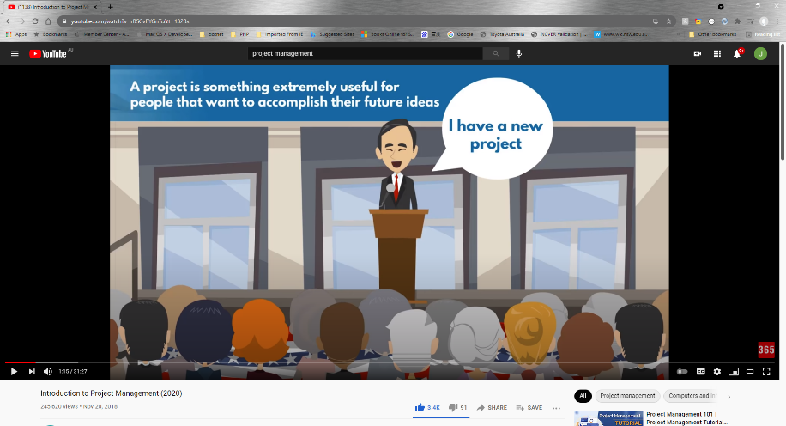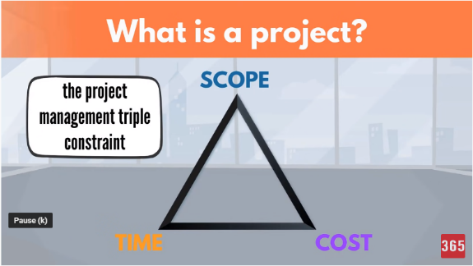

## What is a project?

project need you make a big effect in order to achieve a unique or specific goal. A project need show start date or time and finish date or time

## Project management basic

Project management is the process of leading the work of a team to achieve all project goals within the given constraints. This information is usually described in project documentation, created at the beginning of the development process. The primary constraints are scope, time, and budget.

## Project management History

Good example is: Ancient Egypt build a big project! 20 Century the Henry Gantt first make Gantt Chart Diagram. It is the revolution to know more about project management.

## Project management in the future

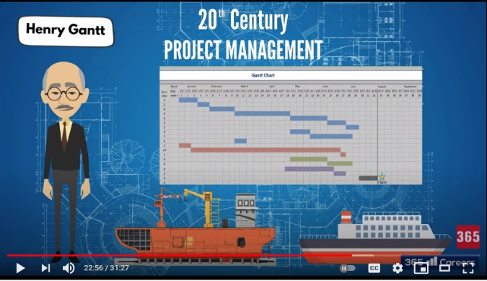There is a growing demand for project managers throughout the world.

## Project Team

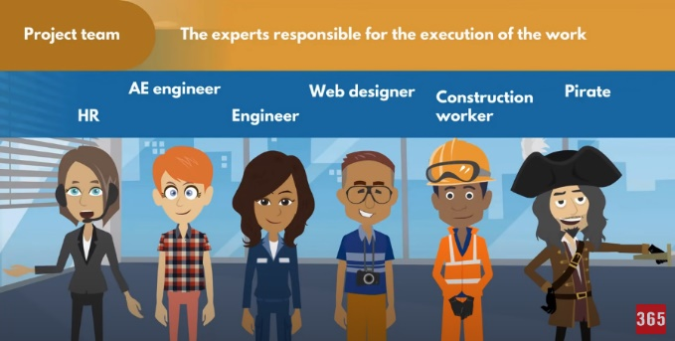In a project, a project team or team is defined as "an interdependent collection of individuals who work together towards a common goal and who share responsibility for specific outcomes of their organizations"

## Document Search Index

A

a GANTT chart 3

M

mission and strategy 5

mission statement 4

O

organizational change 5

P

project stakeholders 3

projects integration 4

S

successful implementation 4

U

understanding risk 5